APPLICATION FOR EMPLOYMENT PRE-EMPLOYMENT
QUESTIONNAIRE
AN EQUAL
OPPORTUNITY EMPLOYER
P.O. Box 1344
514 Speedway Blvd.
Hampton, GA 30228
ClassicLandscapesGa.com
greencareers@ClassicLandscapesGa.com
678-481-3717
770-946-0558 fax

Personal Information
Name (Last Name First) _______________________________________________________
Present Address ____________________________________________________________
Phone Number (s) __________________________________________________________
Are you 18 years or older? Are you legally authorized to work in the US?
Yes No Yes No
Desired Employment
Position ________________ Date you can Start _______________
Salary Desired__________ Have you applied to this company before: Yes No
Are you Employed Now? If so, may we inquire of your present employer?
Yes No Yes No
Name of last supervisor at this company: ___________________________________________
Who referred you to this company? _______________________________________________
How did you find out about this position?
Employment Agency Website Friend
State Employment office College Placement Service Walk In
Education
School Level Name and No. of Years Year Graduated
Location of School Attended
High School __________________________________________________
College _________________________________________________
Trade, Business
Or Correspondence
School ________________________________________________

General
Subjects of Special Study, Training or Skills
_______________________________________________________________
Hobbies/Free Time Interests
_______________________________________________________________
Former Employers

Name of Present or Last Employer ___________________________________________________

Address ___________________________________________________________________
Starting Date _________ Leaving Date ____________ Job Title ___________________________
Weekly Starting Salary ______________ Weekly Final Salary __________________________
May we Contact your Supervisor? Yes No
Name of Supervisor _________________ Title_________________ Phone ________________
Description of Work
____________________________________________________________________________
Reason for Leaving
____________________________________________________________________________

Name of Present or Last Employer ____________________________________________________

Address ___________________________________________________________________
Starting Date ____________ Leaving Date ______________ Job Title____________________
Weekly Starting Salary __________________ Weekly Final Salary __________________________
May we Contact your Supervisor? Yes No
Name of Supervisor ___________________ Title __________________ Phone_______________
Description of Work
____________________________________________________________________________
Reason for Leaving
____________________________________________________________________________

Name of Present or Last Employer__________________________________________________

Address_____________________________________________________________________
Starting Date _____________ Leaving Date _____________ Job _______________________
Weekly Starting Salary _______________ Weekly Final Salary _____________________
May we Contact your Supervisor? Yes No
Name of Supervisor __________________ Title_______________ Phone __________________
Description of Work
____________________________________________________________________________
Reason for Leaving
____________________________________________________________________________

Name of Present or Last Employer__________________________________________________

Address_____________________________________________________________________
Starting Date _____________ Leaving Date _____________ Job _______________________
Weekly Starting Salary _______________ Weekly Final Salary ___________________
May we Contact your Supervisor? Yes No
Name of Supervisor __________________ Title________________Phone __________________
Description of Work
____________________________________________________________________________
Reason for Leaving
____________________________________________________________________________

Name of Present or Last Employer__________________________________________________

Address_____________________________________________________________________
Starting Date _____________ Leaving Date _____________ Job _______________________
Weekly Starting Salary _______________ Weekly Final Salary _____________________
_____________________________
May we Contact your Supervisor? Yes No
Name of Supervisor __________________ Title________________Phone __________________
Description of Work
____________________________________________________________________________
Reason for Leaving
____________________________________________________________________________

Name of Present or Last Employer__________________________________________________

Address_____________________________________________________________________
Starting Date _____________ Leaving Date _____________ Job _______________________
Weekly Starting Salary _______________ Weekly Final Salary ___________________
May we Contact your Supervisor? Yes No
Name of Supervisor __________________ Title_______________ Phone __________________
Description of Work
____________________________________________________________________________
Reason for Leaving
____________________________________________________________________________

References
Below, give the names of three persons you are not related to, whom you have known at least one year.
Name Phone Address Years Acquainted
________________________________________________________________
_________________________________________________________________
__________________________________________________________________
Service Record
Have you ever served in the U.S. Armed Forces? Yes No
Branch of Service Discharge Date Rank
_______________________________________________________________
_______________________________________________________________

Have you ever been convicted of, plead guilty/no contest to, or had a suspended imposition of sentence for any offence (other than a minor traffic violation)? Yes No
If yes, explain
__________________________________________________________________
__________________________________________________________________
__________________________________________________________________
__________________________________________________________________
(A convictional record will not necessarily exclude you from consideration. This information will be used only for job-related purposes and only to the extent permitted by law.)
Authorization
"I CERTIFY THAT THE FACTS CONTAINED IN THIS APPLICATION ARE TRUE AND COMPLETE TO THE BEST OF MY KNOWLEDGE AND UNDERSTAND THAT, IF EMPLOYED, FALSIFIED STATEMENTS ON THIS APPLICATION SHALL BE GROUNDS FOR DISMISSAL.
"I AUTHORIZE INVESTIGATION OF ALL STATEMENTS CONTAINED HEREIN AND THE REFERENCES AND EMPLOYERS LISTED ABOVE TO GIVE YOU ANY AND ALL INFORMATION CONCERNING MY PREVIOUS EMPLOYMENT AND ANY PERTINENT INFORMATION THEY MAY HAVE, PERSONAL OR OTHERWISE AND RELEASE THE COMPANY FROM ALL LIABILITY FOR ANY DAMAGE THAT MAY RESULT FROM UTILIZATION OF SUCH INFORMATION.
"I ALSO UNDERSTAND AND AGREE THAT NO REPRESENTATIVE OF THE COMPANY HAS ANY AUTHORITY TO ENTER INTO ANY
AGREEMENT FOR EMPLOYMENT FOR ANY SPECIFIED PERIOD OF TIME, OF. TO MAKE ANY AGREEMENT CONTRARY TO THE
FOREGOING, UNLESS IT IS IN WRITING AND SIGNED BY AN AUTHORIZED COMPANY REPRESENTATIVE.
"THIS WAIVER DOES NOT PERMIT THE RELEASE OR USE OF DISABILITY-RELATED OR MEDICAL INFORMATION IN A MANNER PROHIBITED BY THE AMERICANS WITH DISABILITIES ACT (ADA) AND OTHER RELEVANT FEDERAL AND STATE LAWS."
________________________________________________________________________
Date Signature
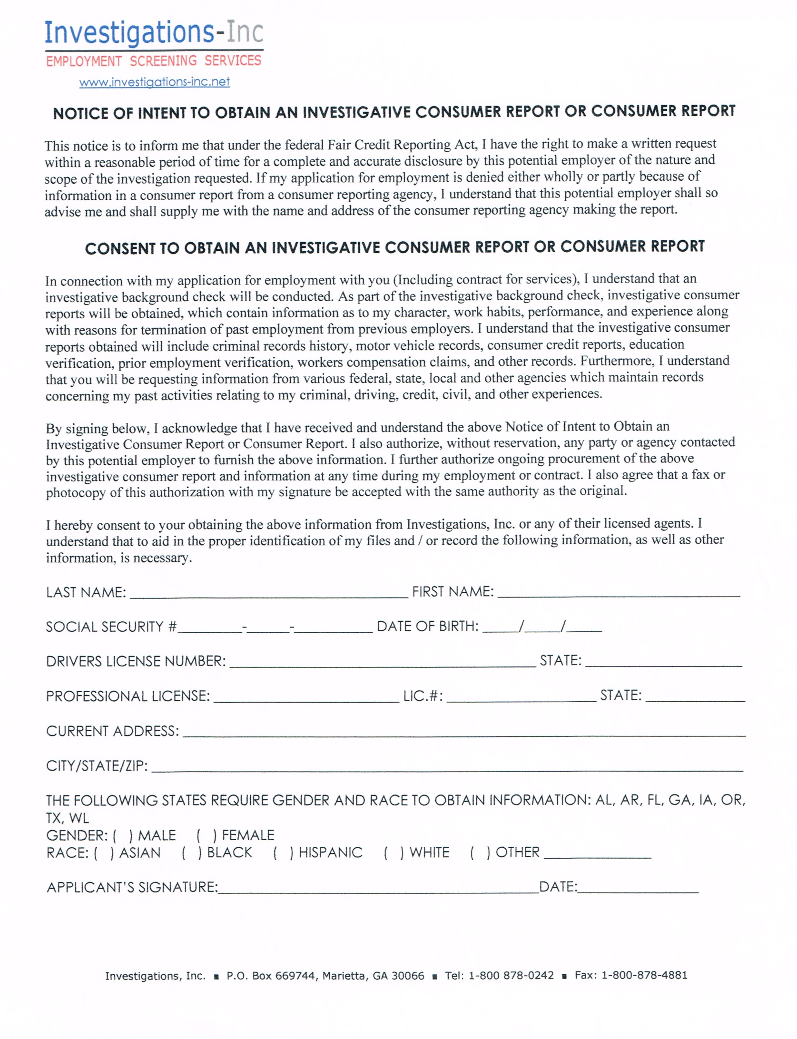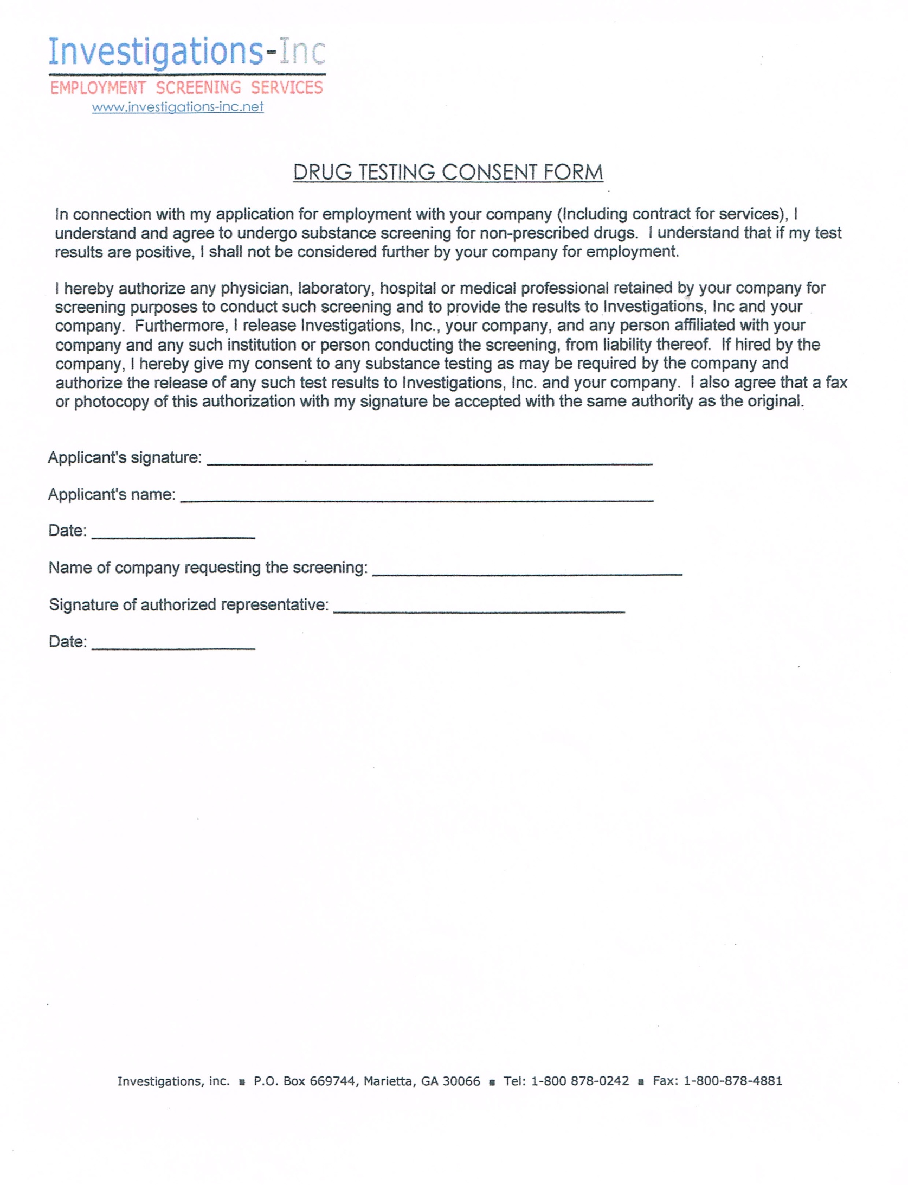
Classic Landscapes, Inc.
514 Speedway Boulevard , Hampton, GA 30228
Phone: (678)481-3717 Fax:

PointeNorth Insurance Group

MOTOR VEHICLE REPORT AUTHORIZATION

I ______________________________ understand that the position that I have applied for or currently hold with Classic Landscapes, Inc. is one that requires driving a motor vehicle and that my driving record must be one that is acceptable to Westfield Companies. I hereby give permission to Westfield Companies and PointeNorth Insurance Group to order, obtain, hold and review with one another, my individual motor vehicle report (MVR).

Name of Applicant/Employee:

Date of Birth:
State Licensed In:
Drivers License Number:

Applicant/Employee Signature:
Date of Signature:
Witnessed By:

